A Robust Criteria Defining Ignition Point in Homogeneous Auto-ignition
Zhaoyu Luo*, Ruiqin Shan, Tianfeng Lu,
University of Connecticut, Storrs, CT 06269
Corresponding Author:
Zhaoyu Luo
Research Assistant
Department of Mechanical Engineering
University of Connecticut
luozy@engr.uconn.edu
Colloquium: Reaction Kinetics
Word Count (Method 1)
Main Text: 2601
Nomenclature: 0
Equations: 2 equations: 2*(1#equation lines+2#blank lines)*7.6words/line*1columns = 46
References: (26 references+2)*2.3lines/reference*7.6 words/line = 490
Tables: 0
Figures and Captions: 1365

Total: 2601+46+1365+490 = 4502 words
Abstract = 197 words

Abstract
Ignition delay is one of the most important properties for engine fuels. Computationally the ignition time in homogeneous auto-ignition system is usually defined as the inflection point on the temperature profile or the instance when temperature increases with certain degree. In the present study, A criteria based on chemical explosive mode (CEM) was proposed for a robust definition of ignition point in combustion simulations. A chemical explosive mode (CEM) is the eigen-mode associated with a positive eigenvalue of the Jacobian of the chemical source term. It has been shown in previous work that CEM plays a critical role in combustion problems such as ignition, extinction and flame propagation, and has been employed as a computational diagnostic technique for some practical CFD simulations including direct numerical simulation (DNS). A reactive mixture in the presence of a CEM is intrinsically explosive and otherwise non-explosive, and can be correspondingly classified as unburned and burned, respectively. In the present study, CEMA is employed to identify the ignition time of the homogeneous iso-octane/air ignition. It is found that CEM can obtain more accurate ignition time of the system compared to other conventional definitions.
Keywords: chemical explosive mode analysis, auto-ignition, iso-octane, reduced mechanism

1. Introduction
Ignition delay time or induction time [1-2] is one of the most important combustion characteristics of different fuels and thus accurate calculation of ignition delay time, especially for the combustion process with practical fuels in gas turbines and other combustion engines, is very important in combustion simulations. However, since combustion modeling is a complicated procedure due to the strong coupling between flows and chemical kinetics [3], it is difficult to detect some critical features such as ignition in combustion modeling. Temperature or an individual species concentration has been employed for computational diagnostics in combustion modeling [4]. For example, in engine simulations it is conventionally defined that ignition occurs when temperature first reaches 2000K in any computation cell [5-7]. Other than temperature profile, OH* concentration, which represents the excited electronic state of OH, is also frequently used as an indicator of flame zones in laser diagnostics and computational analysis [8]. While such scalars have been successful in many studies, their applications can be limited by the complicated flow-chemistry interaction in CFD simulations [9]. Consequently a thorough understanding of the flame characteristics based on such state properties is invariably needed and a robust computational diagnostic technique is desired for complicated CFD studies.
To resolve the complex couplings between flame and flow, several methods based on eigen-analysis have been developed for multi-component combustion problems. The method of computational singular perturbation (CSP) [10-12], which systematically identifies exhausted fast process that algebraically related the fast variables with others, has been applied to analyze complex laminar flow-chemistry interactions [13]. By neglecting the time dependence of the Jacobian in decoupling the modes, CSP can be degenerated to the method of intrinsic low-dimensional manifold (ILDM) [14]. ILDM and CSP have been extensively applied in kinetic mechanism analysis and reduction, as reviewed in Ref. [15]. CSP has also been found to be useful in understanding limit phenomena, such as ignition in flow reactors and extinction of steady-state flames [16-18]. Recently, the method of chemical explosive mode (CEM) analysis (CEMA) was proposed as a systematic flame diagnostic for a variety of flames involving detailed and reduced chemical kinetics [9, 19]. CEMA is based on the eigen-analysis of the Jacobian matrix of the chemical source terms. It has been shown that CEM playing a critical role in affecting explosive chemical processes and in demarcating the burned and unburned mixtures, and has been successfully applied in the computational diagnostics of lifted flame simulations [9, 19]. Compared to conventional diagnostic techniques, CEMA can readily identify the flame locations and clearly revealed the dominant stabilization mechanism in certain flame configuration.
In the present study, CEMA is employed to determine the induction time of homogeneous iso-octane-air ignition under various conditions. A skeletal mechanism for iso-octane was first developed using DRG-based methods. CEMA was then performed to obtain the ignition time of iso-octane-air mixture. The results will be further compared to those obtained by other conventional definitions. The robustness and vigorousness of CEMA as a criterion determining the ignition point is further demonstrated.

2. Chemical explosive mode analysis
The method of CEMA developed in Ref. [9] is first briefly reviewed here. The differential equations of a typical reacting flow can be discretized as:
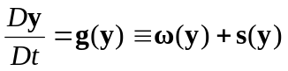 (1)
where D/Dt is the material derivative, and y is the vector of dependent state variables such as species concentrations and temperature. For a reacting flow, g(y) typically includes two terms, the chemical source term , and non-chemical sources term s such as diffusion in flames and the homogeneous mixing term in stirred reactors. The local chemical information is fully encoded in the Jacobian matrix, J, of the chemical source term, . A chemical mode is thereby defined as an eigenmode of J, each associated with an eigenvalue and a corresponding pair of left and right eigenvectors. If the real part of an eigenvalue, _{e}, is positive, we define the corresponding chemical mode as the CEM [9]. Therefore, the existence of a CEM indicates a mixture that is explosive in nature, i.e. the rates tend to grow exponentially along the direction of the eigenvector associated with the CEM if the mixture is left isolated in a lossless environment, in which the term s in Eq. (1) is negligible compared to the chemical source term. While such exponential growth does not necessarily lead to thermal runaway, it is an intrinsic feature of an ignitable mixture.
In an adiabatic homogeneous auto-ignition system, the loss term or the diffusion term s was usually neglected. As such the chemical source term dominates the ignition process. As discussed in Ref. [19], the instance when the eigenvalue λ_{e} of CEM crosses zero is strongly correlated to the time when largest temperature change rate (dT/dt) occurs, which has been widely accepted as the ignition time of homogeneous system. The crossover point of the CEM can separate the unburned mixture which has CEM and is consequently explosive, and the burned mixture, which is non-explosive, having no CEM. As such the crossover point of CEM can be an alternative definition of the ignition point.
In spatially inhomogeneous systems, the CEM interacts with diffusion and other losses. As such, it may not always result in ignition if the magnitude of the CEM is smaller than that of the loss. The competition between the CEM and the loss can be approximately quantified by a Damköhler number defined as
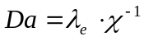, (2)
where  is a reciprocal characteristic time scale of the diffusion or loss term s. A mixture with Da >> 1 then indicates a dominant CEM that will likely result in actual ignition; otherwise ignition may be suppressed as the CEM is strongly strained. The contribution of a chemical species or an elementary reaction to a CEM can be quantified by normalized vector explosive index (EI) and participation index (PI), respectively. More detailed discussion on EI and PI can be found in Ref. [9, 19]. CEM is next applied to determine the ignition time of homogeneous iso-octane-air mixture.

3. Skeletal mechanism for iso-octane
The detailed mechanism for iso-octane, which was developed by Lawrence Livermore National Laboratory [20], was employed with the SENKIN program of CHEMKIN [21-22] to simulate the homogeneous ignition process. The detailed mechanism consists of 874 species and 3796 elementary reactions. While such large mechanism size has rendered it computationally infeasible for current CEMA study, a skeletal mechanism with high chemical fidelity for iso-octane is developed using DRG-based methods [23]. The reduction was sampled over a wide parameter range of pressure from 1 to 50 atm, equivalence ratio 0.3-2, and initial temperature 750-1800K. An improved DRG method was first applied to eliminated unimportant species and reactions [24]. The improved DRG method can achieve a larger extent of reduction comparing to the original method when handling the detailed mechanisms with multiple isomer groups, while it still features similar reduction time and automation compared to the original DRG method. More detailed discussion on the improved DRG can be found in Ref.[24]. After several iterations with the improved DRG method, a skeletal mechanism consisting of 266 species and 1294 reactions was obtained. The DRGASA method [25-26] was applied to further reduce the skeletal mechanism size. Auto-ignition delay and extinction residence time in perfectly stirred reactors (PSR) were targeted in the sensitivity analysis. It is worth noting that while two-stage ignition and the reaction states on the middle brunches of PSR curves of iso-octane can be important for unsteady systems, they are also included in the present sensitivity analysis such that a skeletal mechanism with high chemical fidelity can be obtained. By specifying a worst case error tolerance of 30%, a skeletal mechanism with 143 species and 643 reactions was developed.
The 143-species skeletal mechanism for iso-octane was first validated against the detailed mechanism in homogeneous ignition applications. Figure 1a shows the calculated ignition delay time in constant-pressure auto-ignition as a function of the initial temperature for various pressures. It is seen that the skeletal mechanism can well reproduce the simulated results of the detailed mechanism. Figure 1b further shows the comparison between temperature profiles in auto-ignition at various initial temperatures. The skeletal mechanism shows good agreement with the detailed mechanism for a wide range of temperature. It is also found that the skeletal mechanism can accurately reproduce the two-stage ignition of iso-octane/air mixture under low temperature condition (T0 = 750 K).

4. CEMA criteria for auto-ignition
In the previous investigation of CEMA [9, 19], it was found that CEM plays a critical role in some limited flame phenomena such as auto-ignition, extinction and laminar premixed flames. In the present study, CEMA was used as a criterion defining the ignition time of a homogeneous iso-octane/air mixture. SENKIN program of CHEMKIN [21-22] was used to simulate the homogeneous ignition process.
Figure 2 first shows the magnified profiles of temperature and the eigenvalue, λ_{e}, of the CEM for stoichiometric iso-octane-air mixture at T₀=1200K during adiabatic and constant-pressure auto-ignition. Different ways to define ignition delay time are also shown. While the inflection point on the temperature curve or the time when the temperature reaches to certain degree is widely-accepted to define the ignition time during homogeneous auto-ignition process, the crossover point of the CEM can be an alternative criterion to define the ignition delay since it serves as a separatrix between the unburned and burned mixture [19]. It can be seen in Fig.2 that the ignition delays given by all three definitions are almost identical under the displayed condition. Therefore, different definitions of the ignition delay times can be used interchangeably in some cases since they are quantitatively similar.
Figure 3a further shows the magnified profiles of temperature and the eigenvalue, λ_{e}, of the CEM for lean (ϕ = 0.3) iso-octane-air mixture at T₀=1400K during adiabatic and constant-pressure auto-ignition. It can be observed in Fig.3a that multiple inflection points, marked with the plus signs, exist along the temperature profile. It is also noted that there are two inflection points near thermal run-away instance. Both of them can be candidates defining the ignition point. However, without other physical verifications it would be empirical to select either point to be the ignition point, while the cross-over point on the λ_{e} profile uniquely defines the ignition delay under this condition. Figure 3b further shows the magnified profiles for some major species and the eigenvalue, _{e}, of the CEM under the same condition. It is seen that the inflection points on different species profiles are not identical, and there typically exist multiple inflection points for different species. Therefore, it can be difficult to choose either temperature or a single species concentration to define the ignition point in such case, while CEMA provides an unambiguous and reliable definition instead.
Another conventionally accepted criterion defining the ignition time is using the time when the temperature of the system increases with certain degree, say 400K, during the auto-ignition process. Figure 4 shows the ignition delay as a function of initial temperature for lean iso-octane-air mixture at various pressures. The solid lines plot the ignition delay obtained by the definition of temperature increasing 400K, and the dash lines show the results computed using CEMA. It can be seen in Fig. 4a that both definitions give almost identical ignition delays under low and intermediate temperature ranges (T₀< 1200K), while flat slopes were observed at high temperature when using the temperature criterion under low pressure conditions (p < 50 atm). Since at high temperature the ignition delay decreases when initial temperature goes up, the observation indicates that the temperature criterion might have mis-read the ignition delay of the system under high temperature conditions.
To further scrutinize this issue, figure 4b plots the temperature profiles for lean iso-octane-air mixture at various initial temperatures and atmospheric pressure. The symbols’ face color superimposed to temperature indicates the magnitude of λ_{e} for the CEM. Specifically, CEM exists for the points in red color and is absent for the points in white. The inflection points of each temperature profile have been marked by the plus signs. It can be observed in Fig.4b that multiple inflection points exist under the displayed conditions. It is further seen that at T₀ = 1800K, it takes longer time to achieve equilibrium than the low temperature cases after ignition occurs. Under such conditions the instance obtained by the temperature criterion will fall into the post ignition stage and thereby result in inaccurate ignition delay. It can be further observed in Fig.4b that CEM is absent while the temperature increases with 200-300K under high initial temperature conditions, which indicates that less temperature increases when ignition occurs under high initial temperature conditions. However, it would require expert knowledge to specify the degree. CEM, on the other hand, vigorously defines the cross-over point as the ignition point. As such more accurate ignition delays can be obtained, as shown in the dash line of Fig.4a.
The ignition process in large fuels such as iso-octane feature multi-stage ignition when the initial temperature is low. Figure 5 further shows the temperature profiles of iso-octane-air mixture at low initial temperatures. Again the magnitude of λ_{e} for the CEM was indicated by the symbols’ face color. It can be observed in Fig.5 that two-stage ignition occurs at low initial temperature. It can be further seen in Fig.5 that at the first ignition stage, the inflection point is close to the cross-over point, which well defines the first-stage ignition time. It is difficult to determine the degree of temperature increasing when the temperature criterion is used to obtain the first stage ignition delay since the first stage temperature profiles are different at different initial temperatures. Multiple inflection points were still observed on the temperature profiles at the second ignition stage, while it can be seen that the CEM can readily defined the first and the second ignition points during the two-stage ignition. It is noted that the ignition delay time of constant-pressure ignition is close to that of constant-volume ignition. Therefore, the results herein can also be used for constant-volume applications.
5. Conclusion
The previously developed method of CEMA is extended in the present work as a more robust criterion defining the ignition delay time of homogeneous iso-octane/air ignition. It has been shown that CEM plays a critical role in a variety of combustion phenomena, such as ignition, extinction, and premixed flame propagation. It is emphasized that CEM is a chemical property of the local mixture, and as such CEMA can accurately determine some combustion characteristics such as ignition delay for the ignition applications.
The results obtained by CEM were compared to the data by other conventional definitions for the ignition point of homogenous auto-ignition system. Under certain conditions, the simulated ignition delays given by all three criteria were almost the same, while for some cases it would be more advantage to use the CEM to define the ignition points. For example, when multiple inflection points exist on the temperature and species profiles, it is difficult to determine which inflection point is appropriate being the ignition point without other verifications, while CEM can uniquely identify the ignition point of the system since it has been shown that the cross-over point of CEM can separate the intrinsic burned and unburned mixture. It is further found that another definition using temperature is mostly empirical and might mis-compute the ignition delay under high temperature conditions, while CEM can be widely used over a wide range of temperature, including high temperature and two-stage ignition in the low temperature range.
Acknowledgments

The work at University of Connecticut was supported by the National Science Foundation under Grant 0904771. Any opinions, findings, and conclusions or recommendations expressed in this material are those of the authors and do not necessarily reflect the views of the National Science Foundation.

Reference
1. C.K. Westbrook, and F. Dryer, Combust. Sci. Technol., 27 (1981), 31-43.
2. L.J. Clifford, A.M. Milne, and B.A. Murray, Combust. Flame, 104 (1996), 311-327.
3. T. Lieuwen, V. McDonell, E. Petersen, and D. Santavicca, Journal of Engineering for Gas Turbines and Power, 130 (2008).
4. C.K. Law, Combustion physics, Cambridge University Press, New York, 2006.
5. S.Som, and S.K.Aggarwal, Combust. Flame, 157 (2010), 1179-1193.
6. S. Som, and D.E. Longman, Energy Fuels, 25 (2011), 1373-1386.
7. S. Som, D.E. Longman, A.I. Ramírez, and S.K. Aggarwal, Fuel, 89 (2010), 4014-4024.
8. J.H. Chen, A. Choudhary, B. de Supinski, M. DeVries, E.R. Hawkes, S. Klasky, W.K. Liao, K.L. Ma, J. Mellor-Crummey, N. Podhorszki, R. Sankaran, S. S., and C.S. Yoo, Comp. Sci. Disc., 2 (2009), 015001.
9. T.F. Lu, C.S. Yoo, J.H. Chen, and C.K. Law, J. Fluid Mech., 652 (2010), 45-64.
10. S.H. Lam, Combust. Sci. Technol., 89 (1993), 375-404.
11. S.H. Lam, and D.A. Goussis, Int. J. Chem. Kinet., 26 (1994), 461-486.
12. S.H. Lam, Combust. Sci. Technol., 179 (2007), 767-786.
13. M. Valorani, H.N. Najm, and D.A. Goussis, Combust. Flame, 134 (2003), 35-53.
14. U. Maas, and S.B. Pope, Combust. Flame, 88 (1992), 239-264.
15. K. Seshadri, T.F. Lu, O. Herbinet, S.B. Humer, U. Niemann, W.J. Pitz, R. Seiser, and C.K. Law, Proc. Combust. Inst., 32 (2009), 1067-1074.
16. D.G. Vlachos, L.D. Schmidt, and R. Aris, AIChE J., 40 (1994), 1005-1017.
17. C.G. Fotache, T.G. Kreutz, and C.K. Law, Combust. Flame, 108 (1997), 442-470.
18. A. Kazakov, M. Chaos, Z.W. Zhao, and F.L. Dryer, J. Phys. Chem. A, 110 (2006), 7003-7009.
19. Z. Luo, C.S. Yoo, E.S. Richardson, J.H. Chen, C.K. Law, and T. Lu, Combust. Flame, 159 (2012), 265-274.
20. M. Mehl, H.J. Curran, W.J. Pitz, and C.K. Westbrook, 'Chemical kinetic modeling of component mixtures relevant to gasoline', in 4th European Combustion Meeting (Vienna, Austria, 2009).
21. A.E. Lutz, R.J. Kee, and J.A. Miller, Technical Report SAND87-8248, Sandia National Laboratories (1987).
22. R.J. Kee, F.M. Rupley, and J.A. Miller, 'Chemkin-II: A fortran chemical kinetics package for the analysis of gas-phase chemical kinetics', SAND-89-8009, 1989), p. 127.
23. T.F. Lu, and C.K. Law, Prog. Energy Combust. Sci., 35 (2009), 192-215.
24. Z. Luo, T. Lu, M.J. Maciaszek, S. Som, and D.E. Longman, Energy Fuels, 24 (2010), 6283–6293.
25. X.L. Zheng, T.F. Lu, and C.K. Law, Proc. Combust. Inst., 31 (2007), 367-375.
26. R. Sankaran, E.R. Hawkes, J.H. Chen, T. Lu, and C.K. Law, Proc. Combust. Inst., 31 (2007), 1291-1298.

Figures
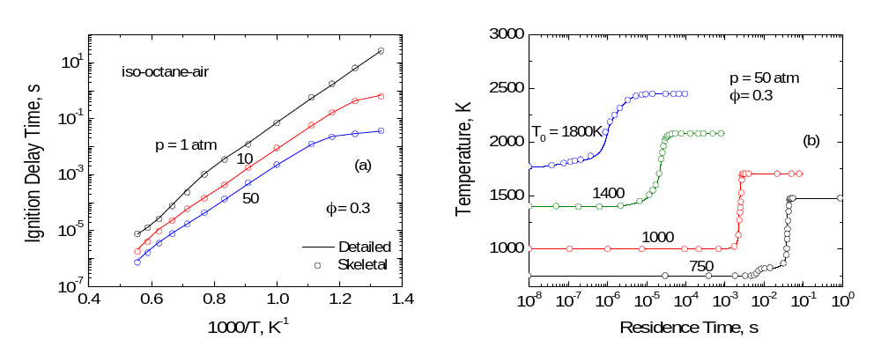
Figure 1: Comparison of the 143-species skeletal mechanism with the detailed mechanism for iso-octane-air mixture on (a) ignition delays and (b) temperature profiles in constant pressure auto-ignition.

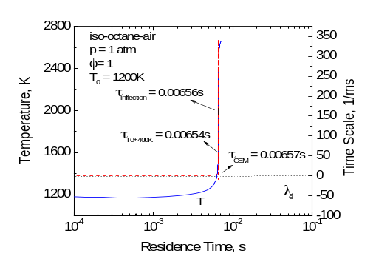
Figure 2: Evolution of temperature and the λ_{e} of the CEM profiles during the homogenous ignition of a stoichiometric iso-octane-air mixture at 1200 K and 1 atm. Three definitions of the ignition delay time are also shown.

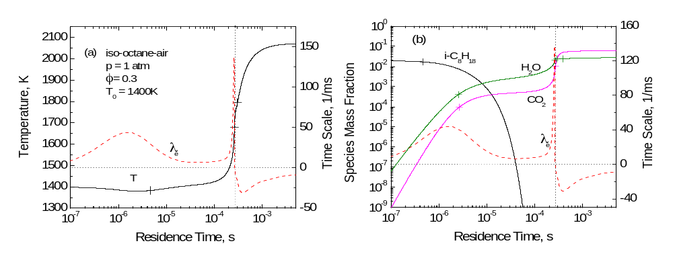
Figure 3: (a) temperature and (b) species mass fractions with λ_{e} profiles in the ignition of lean iso-octane-air mixture under atmospheric pressure and initial temperature of 1400K. The inflection points are marked with plus signs.

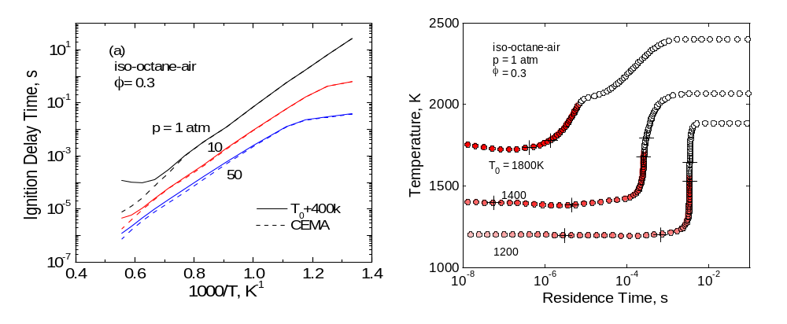
Figure 4: (a) ignition delay as a function of initial temperature for lean iso-octane-air mixture at various pressures, computed using the temperature definition (solid lines) and the CEM (dash lines), respectively; (b) temperature profiles and positive eigen value, log10(1+λe, 1/s), associated with CEM, indicated by the facecolor of the symbols, for auto-ignition of lean iso-octane-air mixture mixtures under atmospheric pressure and various initial temperatures.

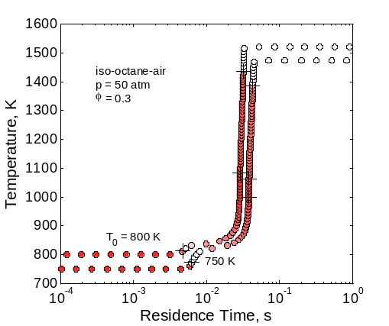
Figure 5. Temperature profiles and positive eigenvalue, log₁₀(1+λ_{e}, 1/s), associated with CEM, indicated by the facecolor of the symbols, for auto-ignition of lean iso-octane-air mixture mixtures at pressure of 50 atm and low initial temperatures.

